**Web PROGRAMMING (3160713)**



**VVP**

**Engineering**

**College**

Submitted by: **DISHEN MAKWANA**

**180470107035**

**G2**

 **V. V. P. Engineering College, Rajkot**

**Department of Computer Engineering**

**Vision of the Department**

* Transforming students into globally efficient professionals with moral values.

**Mission of the Department**

* To provide a strong foundation of computer engineering through effective teaching learning process.
* To enhance industry linkage & alumni network for better placement and real-world exposure.
* To provide various opportunities & platforms for all round development of students & encourage them for value-based practices.

**Assignment 1**

1. **To Study WWW, HTTP Protocol & Web Design Issues.**
2. **WWW:**

* World Wide Web, which is also known as a Web, is a collection of websites or web pages stored in web servers and connected to local computers through the internet. These websites contain text pages, digital images, audios, videos, etc. Users can access the content of these sites from any part of the world over the internet using their devices such as computers, laptops, cell phones, etc. The WWW, along with internet, enables the retrieval and display of text and media to your device.
* Structural Components
* ­ Clients/browsers – to dominant implementations
* ­ Servers – run on sophisticated hardware
* ­ Caches – many interesting implementations
* ­ Internet – the global infrastructure which facilitates data transfer
* Semantic Components
* ­ Hyper Text Transfer Protocol (HTTP)
* ­ Hyper Text Markup Language (HTML)
* ­ Extensible Markup Language (XML)
* ­ Uniform Resource Identifiers (URIs)
* The building blocks of the Web are web pages which are formatted in HTML and connected by links called "hypertext" or hyperlinks and accessed by HTTP. These links are electronic connections that link related pieces of information so that users can access the desired information quickly. Hypertext offers the advantage to select a word or phrase from text and thus to access other pages that provide additional information related to that word or phrase.
* A web page is given an online address called a Uniform Resource Locator (URL). A particular collection of web pages that belong to a specific URL is called a website, e.g., www.vvpedulink.ac.in, www.google.com, etc. So, the World Wide Web is like a huge electronic book whose pages are stored on multiple servers across the world.

1. **HTTP:**

* HTTP provides standard between a web browser and web server to establish communication. It is set of rules for transferring data from one computer to another. Data such as text, images, and other multimedia files are shared on the World Wide Web. Whenever a web user opens their web browser, user will indirectly uses HTTP. It is an application protocol which is used for distributed, collaborative, hypermedia information systems.
* First of all, whenever we want to open any website then first we open web browser after that we will type URL of that website (e.g., www.facebook.com ). This URL is now sent to Domain Name Services (DNS) Then DNS first check records for this URL in their database, then DNS will return IP address to web browser corresponding to this URL. Now browser is able to sent request to actual server.
* After server sends data to client, connection will be closed. If we want something else from server we should have to re-establish connection between client and server.

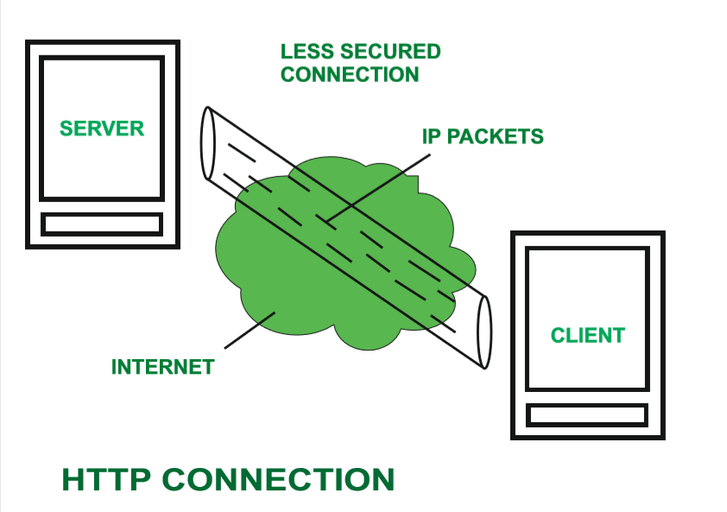

1. **Web Design Issues:**

* Browser & Operating Systems
* Bandwidth and Cache
* Display Resolution
* Look & Feel
* Page Layout and Linking
* Locating Information
* Making Design user-Centric
* Sitemap
* Browser & Operating Systems Web pages are written using different HTML tags and viewed in browser window. The different browsers and their versions greatly affect the way a page is rendered, as different browsers sometimes interpret same HTML tag in a different way. Different versions of HTML also support different sets of tags.
* Bandwidth and Cache Users have different connection speed, i.e. bandwidth, to access the Web sites. Connection speed plays an important role in designing web pages, if user has low bandwidth connection and a web page contains too many images, it takes more time to download. Generally, users have no patience to wait for longer time than 10-15 seconds and move to other site without looking at contents of your web page.
* Display Resolution Display resolution is another important factor affecting the Web page design, as we do not have any control on display resolution of the monitors on which user views our pages. Display or screen resolution is measured in terms of pixels and common resolutions are 800 X 600 and 1024 X 786.
* Look & Feel Look and feel of the website decides the overall appearance of the website. It includes all the design aspects such as ­ Web site theme ­ Web typography ­ Graphics ­ Visual structure ­ Navigation etc…
* Page Layout and Linking Website contains of individual web pages that are linked together using various navigational links. Page layout defines the visual structure of the page and divides the page area into different parts to present the information of varying importance.
* Locating Information Webpage is viewed on a computer screen and the screen can be divided into five major areas such as center, top, right, bottom and left in this particular order. The first major area of importance in terms of users viewing pattern is the center, then top, right, bottom and left in this particular order.
* Making Design user-Centric It is very difficult for any Web designer to predict the exact behavior of the Web site users. However, idea of general behavior of common user helps in making design of the Web site user centric.

1. **You need to explain WWW, How HTTP Works and various web design issues.**
2. **How HTTP Works:**

HTTP REQUEST FORMAT

First type of HTTP message: requests

­ Client browsers construct and send message

Typical HTTP request:

­ GET http://www.vvpedulink.ac.in/index.html HTTP/1.0

request-line ( request request-URI HTTP-version)

headers (0 or more)

<blank line>

body (only for POST request)

HTTP RESPONSE FORMAT

Second type of HTTP message: response

­ Web servers construct and send response messages

Typical HTTP response:

­ HTTP/1.0 301 Moved Permanently

Location: http://www.wisc.edu/cs/index.html

status-line (HTTP-version response-code response-phrase)

headers (0 or more)

<blank line>

body

**Assignment 2**

**To Study and Implement HTML elements with various tags and attribute.**

1. **Demonstrate various html formatting tag.**

Manipulating text in HTML can be tricky; Oftentimes, what you see is NOT what you get. For instance, special HTML tags are needed to create paragraphs, move to the next line, and create headings

<B> Bold Face </B>

<I> Italics </I>

<U> Underline </U>

<P> New Paragraph </P>

<BR> Next Line

•<pre> - preformatted text - it preserves both

spaces and line break

•<i> - Italic text

•<b> - Bold text

•<u> - underlined text

•<strong> - Important text

•<tt> - Teletype text

•<em> - Emphasized text

•<blink> - blink text

•<mark> - Marked text

•<small> - Small text

•<del> - Deleted text

•<ins> - Inserted text

•<sub> - Subscript text

•<sup> - Superscript text

•<strike> - Strikethrough text

•&nbsp; - non breaking space

**<b> and <strong> Elements**

The HTML <b> element defines bold text, without any extra importance. The HTML <strong> element defines text with strong importance. The content inside is typically displayed in bold.

**<i> and <em> Elements**

The HTML <i> element defines a part of text in an alternate voice or mood. The content inside is typically displayed in italic. The HTML <em> element defines emphasized text. The content inside is typically displayed in italic.

**Paragraph <p></p> , Attribute – align,dir,title**

A paragraph always starts on a new line, and browsers automatically add some white space (a margin) before and after a paragraph.

**Horizontal Rules**

The <hr> tag defines a thematic break in an HTML page, and is most often displayed as a horizontal rule.The <hr> element is used to separate content (or define a change) in an HTML page.

**Line Breaks**

The HTML <br> element defines a line break. Use <br> if you want a line break (a new line) without starting a new paragraph.

**Changing the Font**

The expression <FONT FACE = “fontname”> … </FONT> can be used to change the font of the enclosed text To change the size of text use the expression <FONT SIZE=n> …. </FONT> where n is a number between 1 and 7 To change the color, use <FONT COLOR=“red”>…. </FONT>; The color can also be defined using hexadecimal representation ( Example: #ffffff )

These attributes can be combined to change the font, size, and color of the text all at once; For example, <FONT SIZE=4 FACE=“Courier” COLOR=“red”> …. </FONT>

**Headings**

Web pages are typically organized into sections with headings; To create a headinguse the expression <Hn>….</Hn> where n is a number between 1 and 6 In this case, the 1 corresponds to the largest size heading while the 6 corresponds to the smallest size.

<h1> defines the most important heading. <h6> defines the least important heading. Headings Are Important - Search engines use the headings to index the structure and content of your web pages.

**Aligning Text**

The ALIGN attribute can be inserted in the <P> and <Hn> tags to right justify, center, or left justify the text For example, <H1 ALIGN=CENTER> The New York Times </H1> would create a

centered heading of the largest size.

**Comment Statements**

Comment statements are notes in the HTML code that explain the important features of the code

The comments do not appear on the Web page itself but are a useful reference to the author of the page and other programmers To create a comment statement use the <!-- …. --> tags

Example:

<!-- This is a comment --> <p>This is a paragraph.</p>

1. **Demonstrate various list tag with its attributes in html.**

HTML lists allow web developers to group a set of related items in lists.

1. Ordered List

2. Unordered List

3. Definition List

4. Nested List

**1. Ordered Lists**

Ordered lists are a list of numbered items.

To create an ordered list, type:

<OL>

<LI> This is step one.

<LI> This is step two.

<LI> This is step three.

</OL>

The TYPE=x attribute allows you to change the the kind of symbol that appears in the

list.

­ A is for capital letters

­ a is for lowercase letters

­ I is for capital roman numerals

­ i is for lowercase roman numerals

­ 1 is for numbering

By default, an ordered list will start counting from 1. If you want to start counting from a specified

number, you can use the start attribute

**2. Unordered Lists**

An unordered list is a list of bulleted items

To create an unordered list, type:

<UL>

<LI> First item in list

<LI> Second item in list

<LI> Third item in list

</UL>

The TYPE=shape attribute allows you to change the type of bullet that appears

­ circle corresponds to an empty round bullet

­ square corresponds to a square bullet

­ disc corresponds to a solid round bullet; this is the default value.

**3. Description Lists**

A description list is a list of terms, with a description of each term.

The <dl> tag defines the description list, the <dt> tag defines the term (name), and

the <dd> tag describes each term

<dl>

<dt>Title 1</dt>

<dd>- Description</dd>

<dt>Title 2</dt>

<dd>- Description</dd>

</dl>

**4. Nested Lists**

Lists can be nested (list inside list).

<ul>

<li>ABC</li>

<li>PQR

<ul>

<li>P</li>

<li>Q</li>

</ul>

</li>

<li>XYZ</li>

</ul>

1. **Demonstrate table tag with its elements and attributes.**

Tables can be used to display rows and columns of data, create multi-column text, captions for images, and sidebars The <TABLE> tag is used to create a table; the <TR> tag defines the beginning of a row while the <TD> tag defines the beginning of a cell Adding a Border The BORDER=n attribute allows you to add a border n pixels thick around the table To make a solid border color, use the BORDERCOLOR=“color” attribute To make a shaded colored border, use BODERCOLORDARK=“color” and BORDERCOLORLIGHT=“color”

<TABLE BORDER=10>

<TR>

|  |  |
| --- | --- |
| One | Two |
| Three | Four |

<TD>One</TD>

<TD>Two</TD>

</TR>

<TR>

<TD>Three</TD>

<TD>Four</TD>

</TR>

</TABLE>

**Adjusting the Width** When a Web browser displays a table, it often adds extra space. To eliminate this space use the WIDTH=n attribute in the <TABLE> and <TD> tags

Keep in mind - a cell cannot be smaller than its contents, and if you make a table wider than the browser window, users will not be able to see parts of it.

**Centering a Table**

There are two ways to center a table

­ Type <TABLE ALIGN=CENTER>

­ Enclose the <TABLE> tags in opening and closing <CENTER> tags

**Wrapping Text around a Table**

It is possible to wrap text around a table. This technique is often used to keep images and captions

together within an article. To wrap text around a table, type <TABLE ALIGN = LEFT> to align the table to the left while the text flows to the right.

Create the table using the <TR>, <TD>, and </TABLE> tags as you normally would

**Adding Space around a Table**

To add space around a table, use the HSPACE=n and VSPACE=n attributes in the <TABLE> tag

Example:

<TABLE HSPACE=20 VSPACE=20>

**Spanning Cells Across Columns**

It is often necessary to span one cell across many columns. For example, you would use this technique to span a headline across the columns of a newspaper article.

To span a cell across many columns, type <TD COLSPAN=n>, where n is the number of columns to be spanned Spanning Cells Across Rows. To span a cell across many rows, type <TD ROWSPAN=n>, where n is the number of rows.

**Aligning Cell Content**

By default, a cell’s content are aligned horizontally to the left and and vertically in the middle.

Use VALIGN=direction to change the vertical alignment, where “direction” is top, middle, bottom, or baseline Use ALIGN=direction to change the horizontal alignment where “direction” is left, center, or right.

**Controlling Cell Spacing**

Cell spacing is the space between cells while cell padding is the space around the contents of a cell

To control both types of spacing, use the CELLSPACING =n and CELLPADDING=n attributes in the <TABLE> tag

1. **Create below table layout using HTML**

<!DOCTYPE html>

<html lang="en">

<head>

<title>Table</title>

</head>

<body>

<table border="1">

<tr>

<td width="100" height="100">

<ol>

<li>

abc

</li>

<li>

def

</li>

<li>

ghi

</li>

</ol>

</td>

<td width="100" height="100">

<ul>

<li>pqr</li>

<li>xyz</li>

<li>aqa</li>

</ul>

</td>

</tr>

<tr align="center">

<td width="100" height="100">

<a href="www.google.com">Google</a>

</td>

<td width="100" height="100">

<img src="./sci.jpg" alt="Image" height="100px" width="100px" />

</td>

</tr>

</table>

</body>

</html>

<!DOCTYPE html>

<html lang="en">

<head>

<title>Table</title>

</head>

<body>

<table width="500px" height="500px" border="1">

<tr align="center">

<td colspan="4">A</td>

</tr>

<tr align="center">

<td rowspan="2">B</td>

<td colspan="2">C</td>

<td>D</td>

</tr>

<tr align="center">

<td>E</td>

<td>F</td>

<td>G</td>

</tr>

<tr align="center">

<td>H</td>

<td>I</td>

<td colspan="2">J</td>

</tr>

</table>

</body>

</html>

<!DOCTYPE html>

<html lang="en">

<head>

<title>Table</title>

</head>

<body>

<table border="1">

<tr align="center">

<td width="100" height="100">A</td>

<td width="100" height="100">B</td>

<td width="100" height="100">C</td>

</tr>

<tr align="center">

<td width="100" height="100">X<sup>2</sup></td>

<td width="100" height="100">X<sub>2</sub></td>

<td width="100" height="100"><del>X</del></td>

</tr>

<tr align="center">

<td width="100" height="100">

<ol>

<li type="I">Hello</li>

<li style="list-style-type:upper-alpha" type="A">World</li>

</ol>

</td>

<td width="100" height="100">

<ul>

<li type="square">ABC</li>

<li type="circle">PQR</li>

<li type="">XYZ</li>

</ul>

</td>

<td width="100" height="100">

<img src="./Interesting_GIF.gif" alt="Image" height="100px" width="100px" />

</td>

</tr>

</table>

</body>

</html>

<!DOCTYPE html>

<html lang="en">

<head>

<title>Table</title>

</head>

<body>

<table border="1" width="100px" height="100px">

<tr align="center">

<td><b>Position</b></td>

<td><b>Name</b></td>

<td><b>City</b></td>

</tr>

<tr align="center">

<td>Sales Manager</td>

<td>

<ol>

<li>Dishen</li>

<li>Dhruv</li>

</ol>

</td>

<td>

<ol>

<li type="A">UK</li>

<li type="A">Austrelia</li>

</ol>

</td>

</tr>

</table>

</body>

</html>

<!DOCTYPE html>

<html lang="en">

<head>

<title>Table</title>

</head>

<body>

<table border="1" width="200px" height="200px">

<tr align="center">

<td>First</td>

<td>Second</td>

<td>Third</td>

</tr>

<tr align="center">

<td>Computer</td>

<td rowspan="2">Civil</td>

<td></td>

</tr>

<tr align="center">

<td>Results</td>

<td></td>

</tr>

</table>

</body>

</html>

<table border="1" width="400px" height="200px">

<tr align="center">

<td rowspan="2"></td>

<td colspan="3">Exam Time Table</td>

</tr>

<tr align="center">

<td>GreenPark</td>

<td>Oxford</td>

<td>Euston</td>

</tr>

<tr align="center">

<td>12/10/2020</td>

<td>WP</td>

<td>TOC</td>

<td>CU</td>

</tr>

<tr align="center">

<td>13/10/2020</td>

<td>TOC</td>

<td>CU</td>

<td>WP</td>

</tr>

</table>

<table border="1" width="400px" height="200px">

<tr align="center">

<td colspan="2">January</td>

<td>February</td>

</tr>

<tr align="center">

<td rowspan="2">March</td>

<td>1</td>

<td>2</td>

</tr>

<tr align="center">

<td>3</td>

<td>4</td>

</tr>

</table>

<!DOCTYPE html>

<html lang="en">

<head>

<title>Table</title>

</head>

<body>

<table border="1" width="200px" height="200px">

<tr>

<td colspan="4">India</td>

</tr>

<tr>

<td rowspan="2">AUS</td>

<td colspan="2">USA</td>

<td>Spain</td>

</tr>

<tr>

<td>Switerland</td>

<td>Italy</td>

<td rowspan="2">Japan</td>

</tr>

<tr>

<td>China</td>

<td>Myanmar</td>

<td>SouthKorea</td>

</tr>

</table>

</body>

</html>

<table border="1" width="400px" height="200px">

<tr align="center">

<td rowspan="2"></td>

<td colspan="2">Average</td>

<td rowspan="2">Other Category</td>

</tr>

<tr align="center">

<td>Height</td>

<td>Width</td>

</tr>

<tr align="center">

<td>Male</td>

<td>1.9</td>

<td>0.003</td>

<td>YYY</td>

</tr>

<tr align="center">

<td>Female</td>

<td>1.7</td>

<td>0.002</td>

<td>XXX</td>

</tr>

</table>

<!DOCTYPE html>

<html lang="en">

<head>

<title>Table</title>

</head>

<body>

<table border="1" width="400px" height="200px">

<tr align="center">

<td rowspan="3">A</td>

<td>B</td>

<td colspan="2">C</td>

<td>D</td>

<td colspan="2" rowspan="2">E</td>

</tr>

<tr align="center">

<td>F</td>

<td>G</td>

<td rowspan="3">H</td>

<td>I</td>

</tr>

<tr align="center">

<td rowspan="2">J</td>

<td>K</td>

<td>L</td>

<td>M</td>

<td>N</td>

</tr>

<tr align="center">

<td>O</td>

<td>P</td>

<td colspan="3">Q</td>

</tr>

</table>

</body>

</html>

**Assignment 3**

1. **Demonstrate the various form element and its attributes and create one simple registration form as per your requirement.**

HTML <form> Elements

The HTML <form> element can contain one or more of the following form elements:

<input>

<label>

<select>

<textarea>

<button>

<fieldset>

<legend>

<option>

<optgroup>

**The <input> Element**

The HTML <input> element is the most used form element.

An <input> element can be displayed in many ways, depending on

the type attribute.

**Creating Text Boxes**

To create a text box, type <INPUT TYPE=“text” NAME=“name” VALUE=“value” SIZE=n

MAXLENGTH=n>

The NAME, VALUE, SIZE, and MAXLENGTH attributes are optional

**TEXTAREA**

To create larger text areas, type <TEXTAREA NAME=“name” ROWS=n1 COLS=n2 WRAP>

Default Text </TEXTAREA>, where n1 is the height of the text box in rows and n2 is the width

of the text box in characters.

**Creating Radio Buttons**

To create a radio button, type <INPUT TYPE=“radio” NAME=“name” VALUE=“data”>Label,

where “data” is the text that will be sent to the server if the button is checked and “Label” is

the text that identifies the button to the user.

**Creating Checkboxes**

To create a checkbox, type <INPUT TYPE=“checkbox” NAME=“name” VALUE=“value”>Label

If you give a group of radio buttons or checkboxes the same name, the user will only be able

to select one button or box at a time.

**Creating Drop-down Menus**

To create a drop-down menu, type <SELECT NAME=“name” SIZE=n MULTIPLE>

Then type <OPTION VALUE= “value”>Label

In this case the SIZE attribute specifies the height of the menu in lines and MULTIPLE

allows users to select more than one menu option

<optgroup > - Group related options

Attribute of optgroup – label , disabled

Attribute of option – selected , value

**Creating a Submit Button**

To create a submit button, type <INPUT TYPE=“submit”>

If you would like the button to say something other than submit, use the VALUE attribute.

**<label> Element**

The <label> tag defines a label for many form elements.

The <label> element is useful for screen-reader users, because the screen-reader will

read out loud the label when the user focus on the input element.

**Creating a Reset Button**

To create a reset button, type <INPUT TYPE=“reset”>

The VALUE attribute can be used in the same way to change the text that appears on the

Button.

**FIELDSET , LEGEND**

fieldset - group related data in a form

legend - defines a caption for the <fieldset> element.

**Example :**

<!DOCTYPE html>

<html lang="en">

<head>

<title>Dishen</title>

</head>

<body>

<form>

<fieldset style="width: 30%">

<legend>User Info</legend>

<label for="fname">First name:</label><br>

<input type="text" id="fname" name="fname"><br>

<label for="lname">Last name:</label><br>

<input type="text" id="lname" name="lname"><br>

<label for="age">Age:</label><br>

<input type="number" id="age" name="age"><br>

<label for="email">Email:</label><br>

<input type="email" id="email" name="email"><br>

<label for="gender">Gender:</label><br>

<input type="radio" id="male" name="gender" checked>Male<br>

<input type="radio" id="female" name="gender">Female<br>

<label for="phnno">Phone Number:</label><br>

<input type="number" id="phnno" name="phnno"><br>

<label for="hobby">hobby:</label><br>

<input type="checkbox" id="cricket" name="hobby" checked>Cricket<br>

<input type="checkbox" id="coding" name="hobby">Coding<br>

<input type="checkbox" id="learning" name="hobby">Learning<br><br>

<input type="submit" value="Submit">

</fieldset>

</form>

</body>

</html>

1. **Design Login Page HTML. Page must have fields in page Username, Password, Remember Me and Login Button.**

<!DOCTYPE html>

<html lang="en">

<head>

<title>Dishen</title>

</head>

<body>

<form>

<fieldset style="width: 30%">

<legend>User Info</legend><br>

<label for="fname">User name : </label>

<input type="text" id="fname" name="fname"><br><br>

<label for="password">Password : </label>

<input type="password" id="password" name="password"><br><br>

<input type="checkbox" id="remember" name="RememberMe"> Remember Me

<br><br>

<input type="submit" value="Submit">

</fieldset>

</form>

</body>

</html>

1. **Design Registration page in HTML**

<!DOCTYPE html>

<html lang="en">

<head>

<title>Dishen</title>

</head>

<body>

<form>

<fieldset style="width: 30%">

<legend>Registration Form</legend>

<label for="fname">User name : </label><br>

<input type="text" id="fname" name="fname"><br>

<label for="password">Password : </label><br>

<input type="password" id="password" name="password"><br>

<label for="email">Email:</label><br>

<input type="email" id="email" name="email"><br>

<label for="phnno">Phone Number:</label><br>

<input type="number" id="phnno" name="phnno"><br>

<label for="gender">Gender:</label><br>

<input type="radio" id="male" name="gender" checked>Male<br>

<input type="radio" id="female" name="gender">Female<br>

<label for="hobby">hobby:</label><br>

<input type="checkbox" id="cricket" name="hobby" checked>Cricket<br>

<input type="checkbox" id="coding" name="hobby">Coding<br>

<input type="checkbox" id="learning" name="hobby">Learning<br><br>

<label for="Address">Address:</label><br>

<textarea name="feedback" id="feedback" cols="30" rows="10"

wrap="soft">Type Your Feedback here.</textarea><br><br>

<label for="city">Choose a City:</label>

<select name="city" id="city" form="cityform">

<option value="">---Select a card type---</option>

<option value="volvo">abd</option>

<option value="saab">vadodara</option>

<option value="opel" selected>Rajkot</option>

<option value="audi">Surat</option>

</select><br><br>

<label for="state">Choose a State:</label>

<select name="state" id="state" form="stateform">

<option value="">---Select a card type---</option>

<option value="volvo" selected>Gujarat</option>

<option value="saab">Maharastra</option>

<option value="opel">Delhi</option>

<option value="audi">UP</option>

</select><br><br>

<input type="submit" value="Submit">

</fieldset>

</form>

</body>

</html>

1. **Write a form to collect details of a user such as name, address, radio button to choose subject of book he wants to buy, Dropdown to choose favorite author and comments for the last book he read.**

<!DOCTYPE html>

<html lang="en">

<head>

<title>Dishen</title>

</head>

<body>

<form >

<legend style="float:right">User Info</legend>

<label for="fname">First name:</label>

<input type="text" id="fname" name="fname"><br><br>

<label for="lname">Last name:</label>

<input type="text" id="lname" name="lname"><br>

<br>

<label for="address">Address:</label><br>

<textarea name="address" id="adress" cols="30" rows="10" wrap="soft">Type Your Address here.</textarea>

<br>

<label for="book">Subject of Book:</label>

<input type="radio" id="Science" name="book" checked>Science

<input type="radio" id="Commerce" name="book">Commerce

<input type="radio" id="Arts" name="book">Arts

<br><br>

<label for="authors">Favorite Author:</label>

<select name="author" id="author" form="authorform">

<option value="">---Select a Author---</option>

<option value="ram">Ram</option>

<option value="raj">Raj</option>

<option value="gopal">Gopal</option>

<option value="varma">Varma</option>

</select>

<textarea name="feedback" id="feedback" cols="30" rows="10" wrap="soft">Type Your Feedback here.</textarea>

</form>

</body>

</html>

1. **Demonstrate the use of meta tag and character entities.**

<!DOCTYPE html>

<html lang="en">

<head>

<meta charset="UTF-8">

<meta http-equiv="X-UA-Compatible" content="IE=edge">

<meta name="viewport" content="width=device-width, initial-scale=1.0">

<meta name="author" content="DISHEN MAKWANA">

<meta name="keywords" content="HTML, Meta Tag, Metadata">

<meta name="description" content="Learing about Meta Tags.">

<meta name="revised" content="DISHEN MAKWANA, 22/02/2021">

<meta http-equiv="refresh" content="10; url=http://verywellhealth.herokuapp.com/">

<meta http-equiv="cookie" content="userid=DISHEN, expires=Wednesday, 24-Feb-21 23:59:59 GMT;">

<meta http-equiv="Content-Type" content="text/html">

<title>Meta Info</title>

</head>

<body>

<h1>Meta Tag Example so you can not See anything Here</h1>

&pound;

&copy;

&reg;

&cent;

&#8377;

</body>

</html>

1. **Demonstrate the use of frameset and iframe.**

<html>

<head>

<title>

iframe

</title>

</head>

<body>

<iframe src="../Assignment-5/logo.png" height="500" width="500"></iframe>

</body>

</html>

<frameset>

<frameset rows="150,*,260" , cols="*,*" />

<frame name="f1" src="demo.html" scrolling="no" />

<frame name="f2" src="Form.html" scrolling="no" />

<frame name="f3" src="Form.html" scrolling="no" />

<frame name="f4" src="demo.html" scrolling="no" />

<frame name="f5" src="demo.html" scrolling="no" />

<frame name="f5" src="Form.html" scrolling="no" />

</frameset>

**Assignment 4**

**Build the HTML Layout as per predefined requirement.**

1. **Resume Layout as given in your lab.**

<!DOCTYPE html>

<html lang="en-US">

<head class="at-element-marker">

<title>Resume</title>

</head>

<body>

<!-- <fieldset align="center" style="width: 80%"> -->

<!-- <legend>Resume</legend> -->

<table width="850px" align="center" style="border: 3px solid black; border-collapse: collapse;">

<tr>

<td style="padding-right: 30px; padding-left: 30px;">

<div style="text-align: center;">

<h1 style="text-align: center;"><strong>Nicole King</strong></h1>

Sometown, VA 55555 | Cell: (555) 555-5555<br>

Email: nk@somedomain.com •&nbsp;LinkedIn URL</p>

</div>

<h3 style="text-align: center; border-bottom: 0.5px solid black;">Emergency Medical Technician

&blacksquare; EMT-B</h3>

Certified EMT and dedicated member of emergency response teams delivering fast, quality care during

medical emergencies, accidents, fires, natural disasters and other crisis scenarios. Passionate medical

services provider able to remain calm under pressure

and react swiftly in urgent and life-threatening situations

<h3 style="text-align: center; border-bottom: 0.5px solid black;">EMT Skills</h3>

<div>

<div style="display: inline-block;">

<ul style="list-style-type: square;">

<li>Emergency Medicine</li>

<li>lntubations & Infusions</li>

<li>First Aid & CPR</li>

<li>Airway Management</li>

<li>Patient Stabilization</li>

</ul>

</div>

<div style="display: inline-block;">

<ul style="list-style-type: square;">

<li>Patient Assessment & Vitals</li>

<li>Medication & IV Administration</li>

<li>Emergency Vehicle Operations</li>

<li>Ambulatory Transport</li>

<li>Medical Terminology</li>

</ul>

</div>

<div style="display: inline-block;">

<ul style="list-style-type: square;">

<li>Pre-Hospital Emergency Care</li>

<li>Rescue & Medical Equipment</li>

<li>Splinting & Bleeding Control</li>

<li>Patient Care Documentation</li>

<li>Incident Command Systems (ICS)</li>

</ul>

</div>

</div>

<h3 style="text-align: center; border-bottom: 0.5px solid black;">Professional Experience</h3>

<div style="text-align: center;">ABC AMBULANCE COMPANY • Sometown, VA<br> Emergency Medical Technician

(EMT), 2014 to Present</div> <br> Following completion of EMT trainee program, hired as a full-time

EMT by private ambulance company.Work collaboratively with emergency

services personnel in responding to 911-dispatched calls to provide pre-hospital urgent care, life

support and patient transport.

<div>

<h3 style="text-align: center;">Achievements : </h3>

<div>

<ul style="list-style-type: square;">

<li>Leveraged comprehensive knowledge of emergency medicine to assess, treat, stabilize and

transport seriously ill or injured patients to area hospitals and trauma centers.</li>

<br>

<li>Provided skillful medical care to revive and stabilize patients suffering from traumatic

injuries, cardiac arrest, strokes, seizures, drug overdoses, hypothermia and other

serious conditions</li><br>

<li>Calmed and reassured patients and family members, enabling accurate gathering of crucial

information (e.g., allergies, medications,pain levels) to aid in care decisions.</li>

<br>

<li>Served on taskforce that researched, selected and installed GPS navigation system

providing ambulance drivers with real-time traffic and road conditions. This new

technology accelerated emergency response-time by 20% during

a.m. and p.m. rush hours.</li><br>

<li>Honored with "EMT Star" award following recommendation and implementation of inventory

management program that ensured timely replacement of expired medication and outdated

supplies.</li>

</ul>

</div>

</div>

<div>

<h3 style="text-align: center; border-bottom: 0.5px solid black;">Education</h3>

<p style="text-align: center;">DEF COLLEGE • Sometown, VA <br> &hyphen; Accredited by Commission on

Accreditation of Health Education Programs- <br>

<b>Associate of Applied Science in Emergency Medical Services (EMS)</b>

</p>

<b><i>Certifications : </i></b>

<ul style="list-style-type:square;">

<li>Virginia Emergency Medical Technician-Basic (EMT-B)</li>

<li>ACLS, BLS, PALS, First Aid, CPR,AED</li>

<li>Geriatric Education for Emergency Medical Services (GEMS)</li>

<li>Prehospital Trauma Life Support (PHTLS)</li>

<li>Emergency Vehicle Operators Course (EVOC), Virginia</li>

</ul>

</div>

</td>

</tr>

</table>

<!-- </fieldset> -->

</body>

</html>

**Assignment 5**

**Study and Implement different types of Style Sheet with all properties and their values.**

1. **Demonstrate the use of background and text manipulation property.**

<!DOCTYPE html>

<html lang="en">

<head>

<meta charset="UTF-8" />

<meta http-equiv="X-UA-Compatible" content="IE=edge" />

<meta name="viewport" content="width=device-width, initial-scale=1.0" />

<title>Background & Text</title>

<style>

body {

background-image: url('../sci.jpg');

background-repeat: repeat;

background-size: 100px 100px;

}

p {

text-align: center;

color: red;

direction: rtl;

vertical-align: top;

font-family: Arial;

font-style: italic;

border-style: dotted solid double dashed;

border-color: red;

margin: 25px 50px 75px 100px;

padding: 25px 50px 75px 100px;

text-transform: uppercase;

text-indent: 50px;

letter-spacing: 3px;

}

</style>

</head>

<body>

<h1>Hello World</h1>

<p>How are you all?</p>

</body>

</html>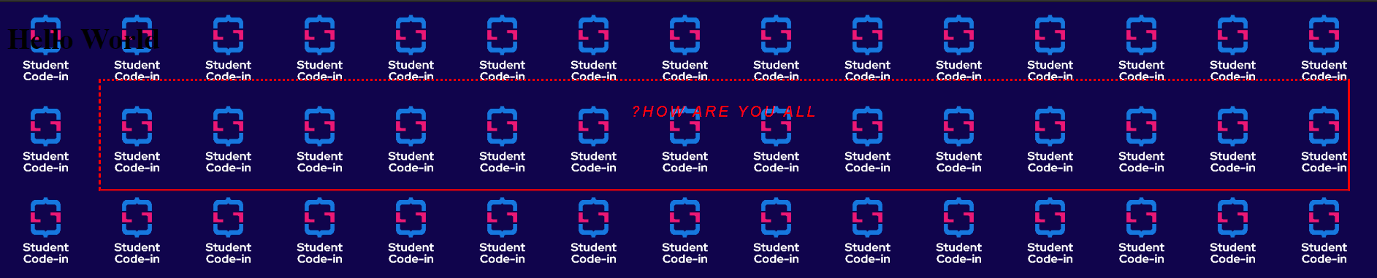

1. **Demonstrate the use of margin, padding and border property.**

<!DOCTYPE html>

<html lang="en">

<head>

<meta charset="UTF-8" />

<meta http-equiv="X-UA-Compatible" content="IE=edge" />

<meta name="viewport" content="width=device-width, initial-scale=1.0" />

<title>Margin Padding Border</title>

<style>

p {

text-align: center;

color: red;

direction: rtl;

vertical-align: top;

font-family: Arial;

font-style: italic;

border-style: dotted solid double dashed;

border-color: red;

margin: 25px 50px 75px 100px;

padding: 25px 50px 75px 100px;

text-transform: uppercase;

text-indent: 50px;

letter-spacing: 3px;

}

</style>

</head>

<body>

<h1>Hello World</h1>

<p>How are you all?</p>

</body>

</html>

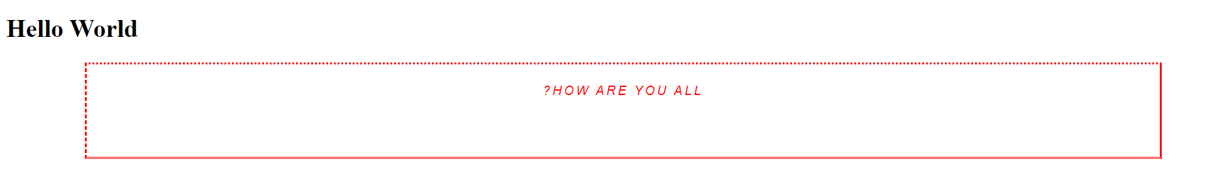

1. **Demonstrate the use of CSS List and Positioning.**

<!DOCTYPE html>

<html lang="en">

<head>

<meta charset="UTF-8" />

<meta http-equiv="X-UA-Compatible" content="IE=edge" />

<meta name="viewport" content="width=device-width, initial-scale=1.0" />

<title>CSS POSITION</title>

<style>

@keyframes example {

from {

background-color: red;

}

to {

background-color: yellow;

}

}

@keyframes animation1 {

0% {

background-color: blue;

top: 0px;

left: 0px;

}

25% {

background-color: red;

top: 0px;

left: 200px;

}

50% {

background-color: yellow;

top: 200px;

left: 200px;

}

75% {

background-color: green;

top: 200px;

left: 0px;

}

100% {

background-color: blue;

top: 0px;

left: 0px;

}

}

.div7 {

width: 100px;

height: 100px;

background-color: red;

animation: example 4s;

animation-iteration-count: 10;

}

.div8 {

width: 100px;

height: 100px;

background-color: blue;

position: relative;

animation: animation1 6s;

animation-iteration-count: infinite;

animation-timing-function: cubic-bezier(0.165, 0.84, 0.44, 1);

animation-fill-mode: backwards;

}

div {

width: 100px;

height: 100px;

}

.div1 {

border: 3px solid red;

position: static;

top: 100px;

left: 100px;

z-index: -1;

}

.div2 {

border: 3px solid green;

position: absolute;

top: 50px;

left: 50px;

z-index: 1;

}

.div3 {

border: 3px solid blue;

position: relative;

top: 25px;

left: 25px;

}

.div4 {

border: 3px solid aquamarine;

position: fixed;

bottom: 50px;

right: 50px;

}

.tooltip {

position: relative;

display: inline-block;

border-bottom: 1px dashed blue;

}

.tooltiptext {

visibility: hidden;

width: 100px;

background-color: #d3d3d3;

color: aquamarine;

text-align: center;

padding: 3px 2px;

border-radius: 5px;

position: absolute;

z-index: 1;

}

.tooltip:hover .tooltiptext {

visibility: visible;

}

ul {

list-style-type: disc;

/* list-style-image: url('../sci.jpg'); */

list-style-position: inside;

}

</style>

</head>

<body>

<div class="div1">Hello World</div>

<div class="div2">VVP</div>

<div class="div5">Hosiyar</div>

<div class="div3">6th Sem</div>

<!-- <div class="div4">G2</div>

<div class="div5">Hosiyar</div> -->

<div class="div6">Hosiyar</div>

<div class="div6">Hosiyar</div>

<!-- <div class="div7">KeyFrame</div> -->

<!-- <div class="div8">KeyFrame2</div> -->

<div class="tooltip">

Hover over me

<span class="tooltiptext">Tooltiptext</span>

</div>

<div class="div7">

<ol>

<li>A X</li>

<li>B Y</li>

<li>C Z</li>

</ol>

<ul>

<li>ABC</li>

<li>XYZ</li>

<li>PQR</li>

</ul>

</div>

</body>

</html>

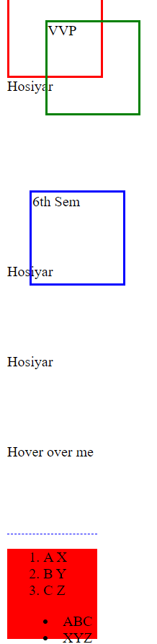

1. **Demonstrate the use of CSS Gradients.**

<!DOCTYPE html>

<html lang="en">

<head>

<meta charset="UTF-8" />

<meta http-equiv="X-UA-Compatible" content="IE=edge" />

<meta name="viewport" content="width=device-width, initial-scale=1.0" />

<title>GRADIENT</title>

<style>

div {

height: 300px;

background-color: aqua;

/*background-image: linear-gradient(green, yellow);*/

background-image: linear-gradient(to right, green, yellow);

background-image: linear-gradient(to bottom right, green, yellow);

background-image: linear-gradient(

to right,

violet,

indigo,

blue,

green,

yellow,

orange,

red

);

background-image: radial-gradient(

circle,

red 10%,

green 40%,

yellow 50%

);

}

</style>

</head>

<body>

<div></div>

</body>

</html>



1. **Demonstrate the use of CSS Animation.**

<!DOCTYPE html>

<html lang="en">

<head>

<meta charset="UTF-8" />

<meta http-equiv="X-UA-Compatible" content="IE=edge" />

<meta name="viewport" content="width=device-width, initial-scale=1.0" />

<title>CSS POSITION</title>

<style>

@keyframes example {

from {

background-color: red;

}

to {

background-color: yellow;

}

}

@keyframes animation1 {

0% {

background-color: blue;

top: 0px;

left: 0px;

}

25% {

background-color: red;

top: 0px;

left: 200px;

}

50% {

background-color: yellow;

top: 200px;

left: 200px;

}

75% {

background-color: green;

top: 200px;

left: 0px;

}

100% {

background-color: blue;

top: 0px;

left: 0px;

}

}

.div7 {

width: 100px;

height: 100px;

background-color: red;

animation: example 4s;

animation-iteration-count: 10;

}

div {

width: 100px;

height: 100px;

}

</style>

</head>

<body>

<div class="div7">KeyFrame</div>

<div class="tooltip">

Hover over me

<span class="tooltiptext">Tooltiptext</span>

</body>

</html>

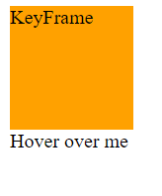

1. **Demonstrate the use of CSS Variables.**

<!DOCTYPE html>

<html lang="en">

<head>

<meta charset="UTF-8" />

<meta http-equiv="X-UA-Compatible" content="IE=edge" />

<meta name="viewport" content="width=device-width, initial-scale=1.0" />

<title>Variable</title>

<style>

:root {

--blue: #1e90ff;

--white: #ffffff;

}

body {

background-color: var(--blue);

}

h2 {

border-bottom: 2px solid var(--blue);

}

p {

--blue: #0000ff;

color: var(--blue);

background-color: var(--white);

padding: 15px;

}

</style>

</head>

<body>

<h2>Hello World</h2>

<p>I am CSS Variable</p>

</body>

</html>



1. **Demonstrate the use of CSS Pseudo Class & Pseudo Elements.**

<!DOCTYPE html>

<html lang="en">

<head>

<meta charset="UTF-8" />

<meta http-equiv="X-UA-Compatible" content="IE=edge" />

<meta name="viewport" content="width=device-width, initial-scale=1.0" />

<title>PSEUDO</title>

<style>

a:link {

color: #ff0000;

}

a:visited {

color: #00ff00;

}

a:hover {

color: #ff00ff;

}

a:active {

color: #0000ff;

}

div.first:hover {

background-color: aqua;

}

div.first p::first-line {

color: #ff00ff;

}

input:focus {

border: 1px solid green;

}

input:hover {

border: 1px solid red;

}

</style>

</head>

<body>

<a href="https://google.com" target="_blank">GOOGLE</a>

<div class="first">

Hello World

<a href="https://gtu.ac.in">GTU</a>

<p>

Lorem ipsum dolor sit, amet consectetur adipisicing elit. Qui

obcaecati beatae laborum commodi vel, ex sit labore dolore,

corporis consequuntur odit. Totam laboriosam, laudantium

repellendus quae voluptatibus architecto molestias beatae!

</p>

</div>

<div class="second">

<h1>Hello World</h1>

</div>

</body>

</html>

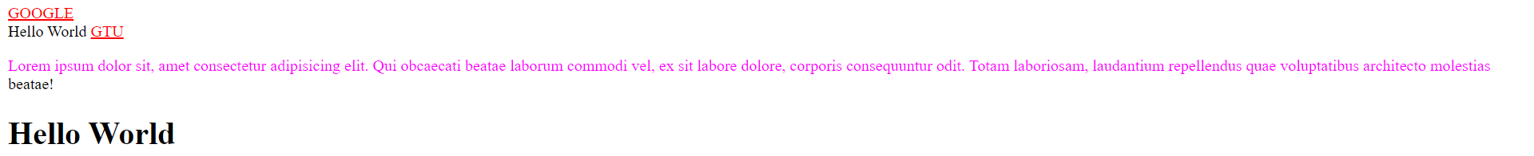

1. **Write down HTML/CSS code to create table with 5 rows and 3 columns. Even no. of rows displays in green color and odd no. of rows display in yellow color.**

<!DOCTYPE html>

<html lang="en">

<head>

<meta charset="UTF-8" />

<meta http-equiv="X-UA-Compatible" content="IE=edge" />

<meta name="viewport" content="width=device-width, initial-scale=1.0" />

<title>Table with CSS</title>

<style>

table {

border: 1px solid blue;

width: 300px;

height: 300px;

text-align: center;

margin-left: auto;

margin-right: auto;

}

tr {

align-items: center;

border: 1px solid green;

}

td:hover {

background-color: aqua;

}

tr:nth-child(odd) {

background-color: aquamarine;

}

tr:nth-child(even) {

background-color: azure;

}

</style>

</head>

<body>

<table>

<thead>

<th>A</th>

<th>B</th>

<th>C</th>

<th>D</th>

<th>E</th>

</thead>

<tbody>

<tr>

<td>1</td>

<td>2</td>

<td>3</td>

<td>4</td>

<td>5</td>

</tr>

<tr>

<td>1</td>

<td>2</td>

<td>3</td>

<td>4</td>

<td>5</td>

</tr>

<tr>

<td>1</td>

<td>2</td>

<td>3</td>

<td>4</td>

<td>5</td>

</tr>

<tr>

<td>1</td>

<td>2</td>

<td>3</td>

<td>4</td>

<td>5</td>

</tr>

</tbody>

<tfoot>

<td>.</td>

<td>.</td>

<td>.</td>

<td>.</td>

<td>.</td>

</tfoot>

</table>

</body>

</html>



1. **Specify the CSS to provide; link: after visited blue color and before visited red color, table with odd rows white and even rows blue color.**

<!DOCTYPE html>

<html lang="en">

<head>

<meta charset="UTF-8" />

<meta http-equiv="X-UA-Compatible" content="IE=edge" />

<meta name="viewport" content="width=device-width, initial-scale=1.0" />

<title>Task</title>

<style>

body {

background-image: url('../sci.jpg');

background-repeat: repeat;

background-size: 100px 100px;

}

.ul {

list-style-type: square;

background-color: aqua;

}

a:link {

color: blue;

}

a:visited {

color: red;

}

table {

border: 1px solid blue;

width: 300px;

height: 300px;

text-align: center;

margin-left: auto;

margin-right: auto;

}

tr {

align-items: center;

border: 1px solid green;

}

td:hover {

background-color: aqua;

}

tr:nth-child(odd) {

background-color: aquamarine;

}

tr:nth-child(even) {

background-color: azure;

}

p {

color: green;

text-indent: 2rem;

text-transform: uppercase;

}

</style>

</head>

<body>

<ul class="ul">

<li>DISHEN</li>

<li>MAKWANA</li>

</ul>

<br />

<img src="../Interesting_GIF.gif" alt="GIF" />

<br />

<a href="https://gtu.ac.in">GTU</a>

<br />

<table>

<thead>

<th>A</th>

<th>B</th>

<th>C</th>

<th>D</th>

<th>E</th>

</thead>

<tbody>

<tr>

<td>1</td>

<td>2</td>

<td>3</td>

<td>4</td>

<td>5</td>

</tr>

<tr>

<td>1</td>

<td>2</td>

<td>3</td>

<td>4</td>

<td>5</td>

</tr>

<tr>

<td>1</td>

<td>2</td>

<td>3</td>

<td>4</td>

<td>5</td>

</tr>

<tr>

<td>1</td>

<td>2</td>

<td>3</td>

<td>4</td>

<td>5</td>

</tr>

</tbody>

<tfoot>

<td>.</td>

<td>.</td>

<td>.</td>

<td>.</td>

<td>.</td>

</tfoot>

</table>

<!-- <br> -->

<p>

Lorem ipsum dolor sit, amet consectetur adipisicing elit. Qui

obcaecati beatae laborum commodi vel, ex sit labore dolore, corporis

consequuntur odit. Totam laboriosam, laudantium repellendus quae

voluptatibus architecto molestias beatae!

</p>

</body>

</html>

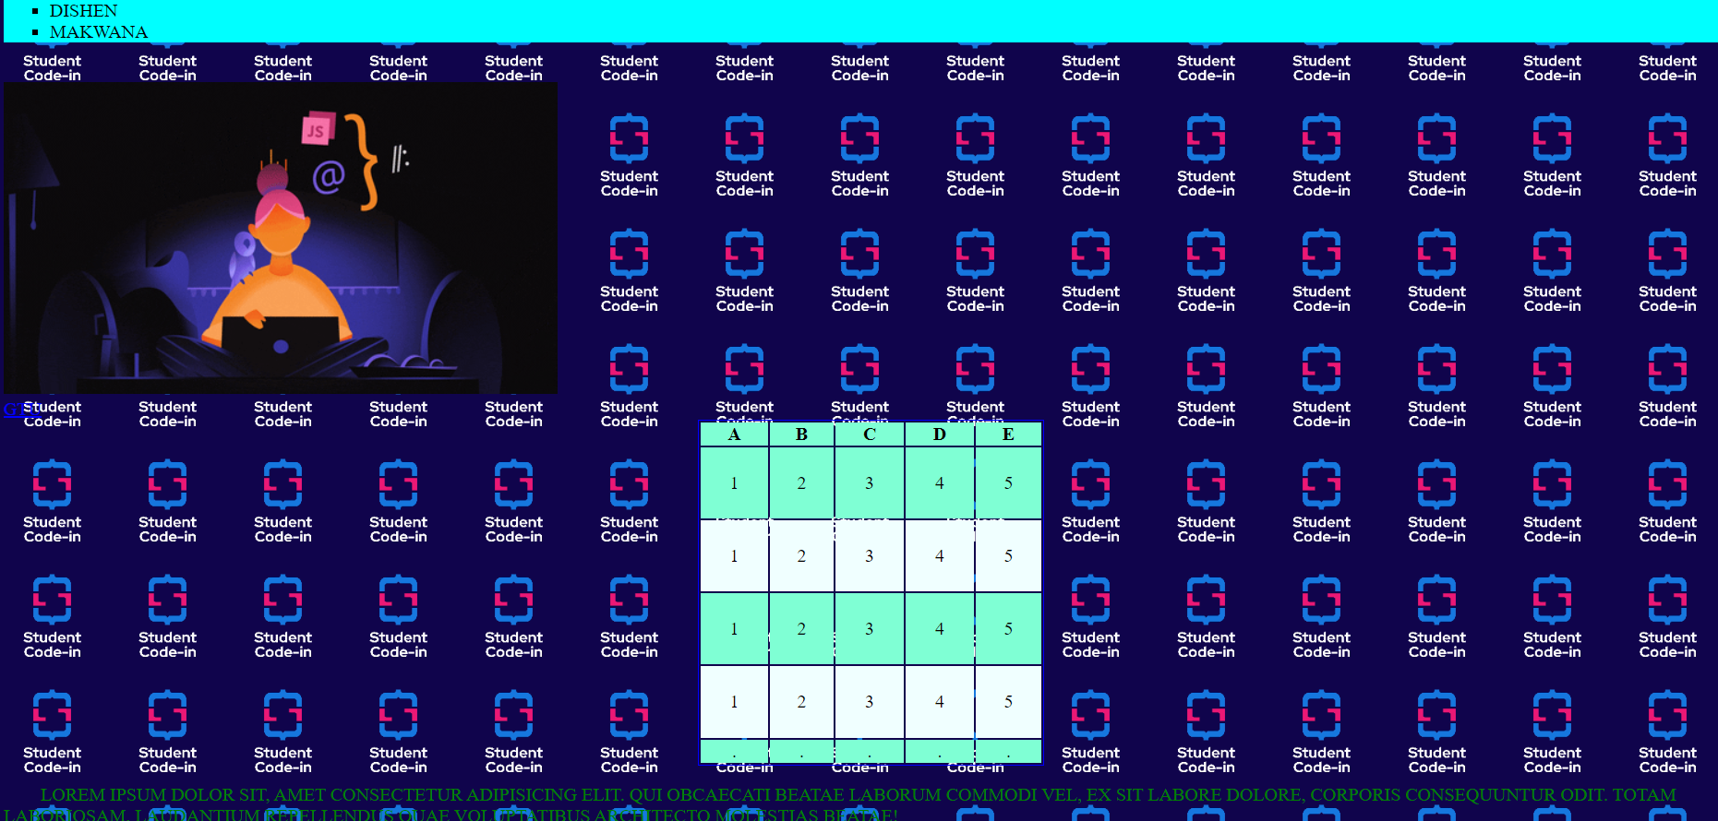

**10. Write cascading style sheet to get following formatting for the paragraph.**

**Text color-green, Text-indentation – 2 cm, Font-courier, Font style-italic**

**Text case-uppercase**

<!DOCTYPE html>

<html lang="en">

<head>

<meta charset="UTF-8" />

<meta http-equiv="X-UA-Compatible" content="IE=edge" />

<meta name="viewport" content="width=device-width, initial-scale=1.0" />

<title>Demo</title>

<style>

p {

color: green;

text-indent: 2cm;

font-family: courier;

font-style: italic;

text-decoration: uppercase;

}

</style>

<link rel="stylesheet" href="style.css" />

</head>

<body>

<h1>Hello World</h1>

<p>How are you all?</p>

</body>

</html>

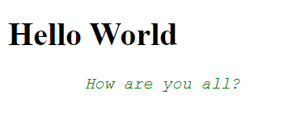

**Assignment 6**

**Build HTML & CSS Webpage as per predefined requirement.**

**1. GMAIL SIGNUP LAYOUT**

<html>

<head>

<meta name="viewport" content="width=device-width, initial-scale=1">

<link rel="stylesheet" href="style.css">

</head>

<body>

<div class="header">

<div class="hleft">

<img src="logo1.png" height="30px" width="100px">

</div>

<div class="hright">

<button>Sign up</button>

</div>

</div>

<div class="main">

<div class="container">

<div class="side-bar">

<h3 style="color:red;float:center; display:block;text-align:left;margin-left:7px;">Create a new Google Account</h3><br>

<div class="container2"> <div class="img-inline"><img src="gmailp.png" style="align-items: left;"></div>&nbsp;&nbsp;&nbsp;<div class="text-inline">Lorem ipsum dolor sit amet consectetur adipisicing elit. Perferendis, modi. Quo est error veritatis qui illo a porro, saepe excepturi harum hic architecto impedit commodi, accusantium aspernatur, explicabo assumenda illum. Your Gmail account is more than ur account</div>

</div>

</div>

<div class="parent">

<div class="table1">

<table cellpadding="5px">

<tr>

<td colspan="2">

<label id="lab"><b>Name</b></label>

</td>

</tr>

<tr>

<td>

<input type="text" id="inp"

placeholder="First">

</td>

<td>

<input id="inp" type="text"

placeholder="Last">

</td>

</tr>

<tr>

<td colspan="2">

<label id="lab"><b>Choose Your Username</b></label>

</td>

</tr>

<tr>

<td colspan="2">

<input type="text" id="inp"

style="width:350px; height:30px">

</td>

</tr>

<tr>

<td colspan="2">

<label id="lab"><b>Create a Password</b></label>

</td>

</tr>

<tr>

<td colspan="2">

<input type="password" id="inp"

style="width:350px; height:30px">

</td>

</tr>

<tr>

<td colspan="2">

<label id="lab"><b>Confirm your Password</b></label>

</td>

</tr>

<tr>

<td colspan="2">

<input type="password" id="inp"

style="width:350px; height:30px">

</td>

</tr>

<tr>

<td colspan="2">

<label id="lab"><b>Birthday</b></label>

</td>

</tr>

<tr>

<td colspan="2">

<div style="width: 100%">

<select class="month" name="month">

<option value="month" selected>Month</option>

<option value="jan">January</option><br>

<option class="opt" value="feb">Februray</option><br>

<option class="opt" value="mar">March</option><br>

<option class="opt"

value="aprl">April</option><br>

<option class="opt" value="may">May</option><br>

<option class="opt"

value="june">June</option><br>

<option class="opt"

value="july">July</option><br>

<option class="opt" value="aug">August</option><br>

<option class="opt"

value="sept">September</option><br>

<option class="opt" value="oct">October</option><br>

<option class="opt" value="nov">November</option><br>

<option class="opt" value="dec">December</option><br>

</select>

<input type="text" class="elements"

id="day" name="Day"

placeholder="Day">

<input type="text" class="elements"

id="year" name="Year"

placeholder="Year"><br>

</div>

</td>

</tr>

<tr>

<td colspan="2">

<label id="lab"><b>Gender</b></label>

</td>

</tr>

<tr>

<td colspan="2">

<select name="gender" class="elements

gender">

<option value="i am" selected

disabled hidden>I am...</option>

<option value="female" class="opt">Female</option><br>

<option value="male" class="opt">Male</option><br>

<option value="other" class="opt">Other</option><br>

<option value="notsay">Rather not

say</option>

</select>

</td>

</tr>

<tr>

<td colspan="2">

<label id="lab"><b>Mobile Phone</b></label>

</td>

</tr>

<tr>

<td colspan="2">

<input type="text" class="elements"

style="height: 34px;" value="+91">

</td>

</tr>

<tr>

<td colspan="2">

<label id="lab"><b>Your current email

address</b></label>

</td>

</tr>

<tr>

<td colspan="2">

<input type="text" class="elements"

style="height: 34px;">

</td>

</tr>

<tr>

<td colspan="2">

<label id="lab"><b>Prove you are not a

robot</b></label>

</td>

</tr>

<tr>

<td colspan="2">

<input type="checkbox">Skip this

verification(Phone verification may be

required)

</td>

</tr>

<tr>

<td colspan="2">

<img src="captcha1.png" width="380px">

</td>

</tr>

<tr>

</tr>

<tr>

<td colspan="2">

<label id="lab"><b>Location</b></label>

</td>

</tr>

<tr>

<td colspan="2">

<select name="gender" class="elements

gender">

<option value="i am" selected

disabled hidden>India</option>

<option value="female" class="opt">Female</option><br>

</select>

</td>

</tr>

<tr>

<td colspan="2">

<input type="checkbox">I agree to the

Google <a href="#">Terms of Service</a>

and <a href="#">Privacy Policy</a>

</td>

</tr>

<tr>

<td colspan="2">

<input type="checkbox" checked>Google

may use my account information to <br>personalize

+1's content and ads on<br>non-Google

websites. <a href="#">About

Personalization</a>

</td>

</tr>

<tr>

<td></td>

<td>

<input value="Next Step" class="s-button

ns-button">

</td>

</tr>

</table>

</div>

</div>

</div>

</div>

</div>

</div>

</body>

</html>

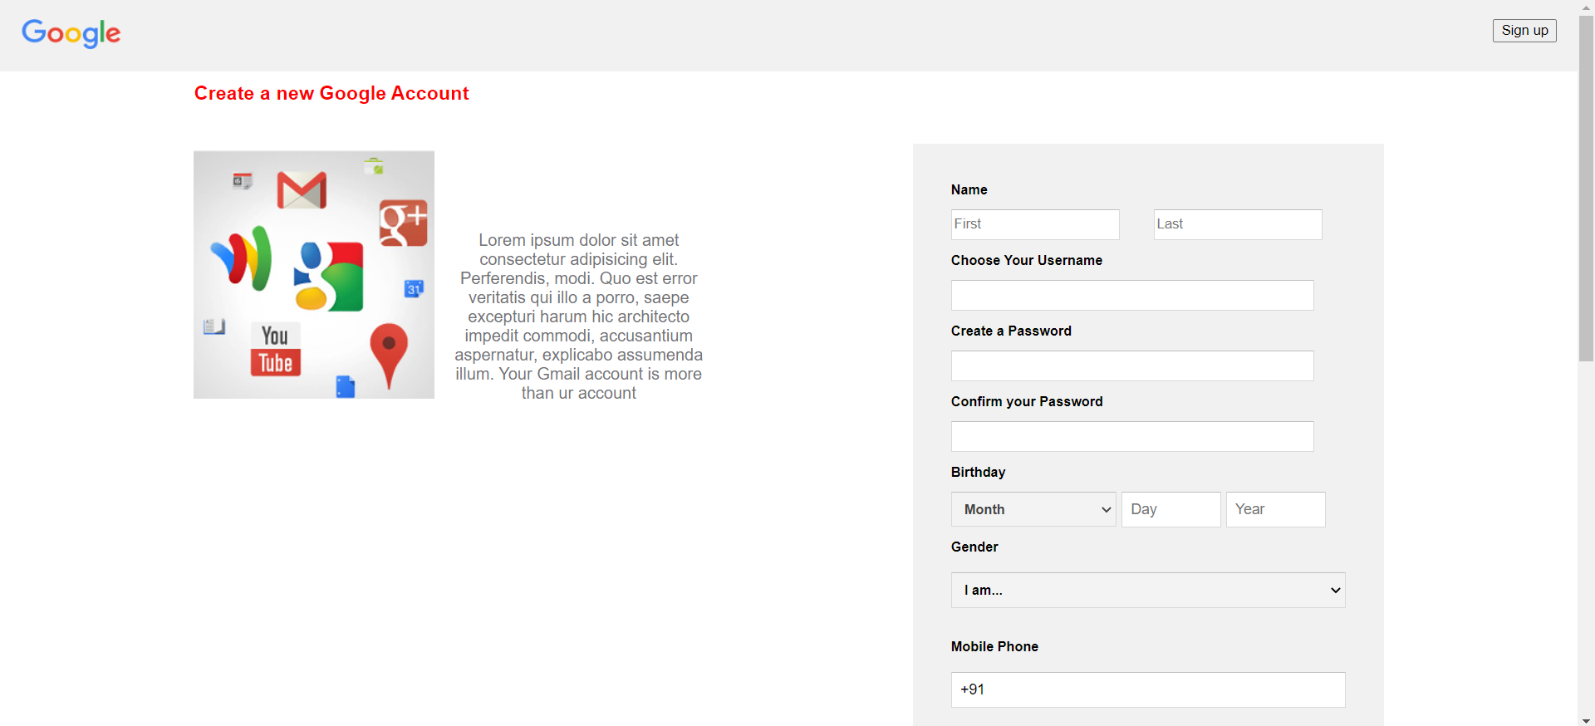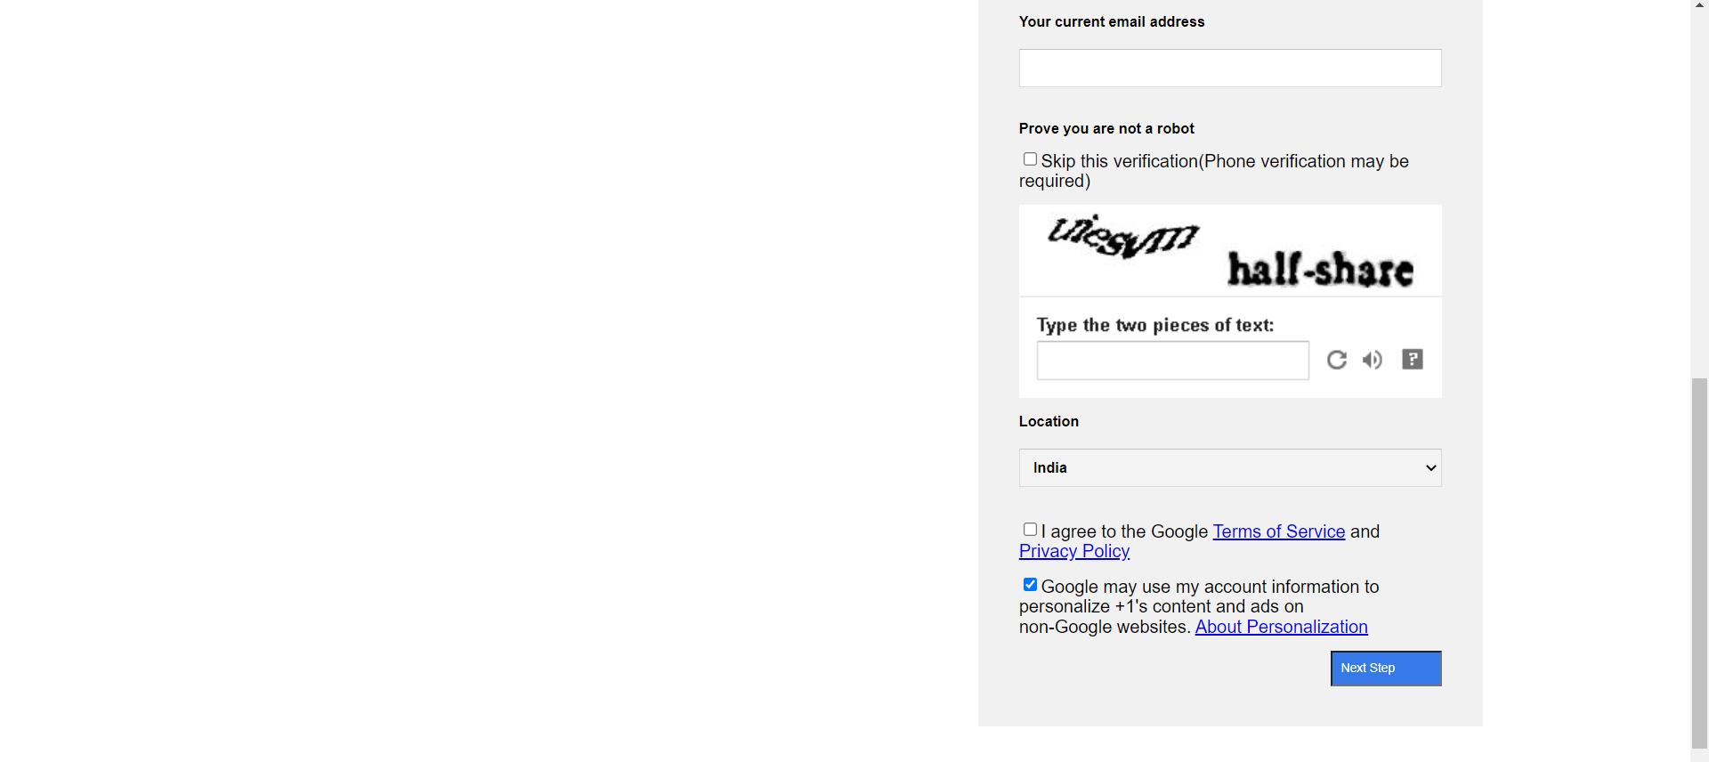

**Assignment 7**

**Study and Implement JavaScript with function and procedure.**

1. **Write an HTML and JavaScript program which accepts N as input and displays first N Fibonacci numbers as list.**

<html>

<head>

<script>

function Prime() {

var i,

flag = 0,

number;

number = Number(document.getElementById('N').value);

for (i = 2; i <= number / 2; i++) {

if (number % i == 0) {

flag = 1;

break;

}

}

if (flag == 0) {

document.getElementById('prime').innerHTML =

"It's a prime number";

} else {

document.getElementById('prime').innerHTML =

"It's not a prime number";

}

}

</script>

</head>

<body>

<br />

<h1>Check Whether a number is Prime or not</h1>

Enter Number :<input type="text" name="n" id="N" />

<button onClick="Prime()">submit</button>

<h3 id="prime"></h3>

</body>

</html>

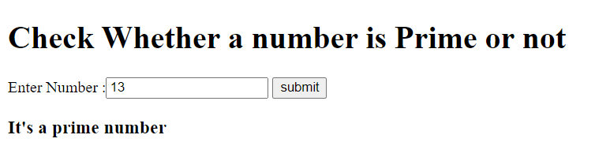

1. **Write a JavaScript, that uses function to calculate how many days are left in your birthday.**

<html>

<head>

<script type="text/javascript">

var month = parseInt(

prompt('enter your birth month (1- 12)', '') - 1

);

var day = parseInt(prompt('enter your birth day(1-31)', ''));

var birthday = new Date();

var currentdate = new Date();

var one_day = 1000 * 60 * 60 * 24;

document.write('Current date : ' + currentdate + '<br>');

birthday.setDate(day);

birthday.setMonth(month);

document.write('Birthday : ' + birthday + '<br>');

var theDate = birthday - currentdate;

theDate = theDate / one_day;

document.write(

'Days left are ' + theDate.toFixed(0) + ' in your birthday '

);

</script>

</head>

</html>

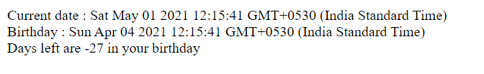

1. **Write a JavaScript, that uses a loop, that searches a word in sentence held in an array, returning the index of word.**

<html>

<head>

<script type="text/javascript">

var word = prompt('Enter a word you want to search for:', '');

document.write('Entered Word : ' + word + '<br>');

var string =

'Lorem ipsum, dolor sit amet consectetur adipisicing elit. Explicabo qui dignissimos aliquid eveniet tenetur, iste provident reprehenderit! Ullam omnis alias ex facere, illum vel ab vitae quisquam perspiciatis nobis quod. Dignissimos tenetur itaque optio unde tempora quidem modi recusandae, cum, cumque voluptatum asperiores esse perferendis? Sunt, deserunt ipsum molestias obcaecati in ab officiis praesentium necessitatibus dolores animi sint, perspiciatis possimus! Suscipit doloribus quaerat veniam similique? Mollitia, saepe tenetur quos quam totam odio accusantium minima fuga atque porro perspiciatis! Soluta, aliquam. Libero quae assumenda rerum alias pariatur? Doloribus ad rerum beatae? ';

var index = string.search(word);

if (index == -1) {

index = 'Word not found';

}

document.write('Enter word position : ', index);

</script>

</head>

<body>

<h2>

Lorem ipsum, dolor sit amet consectetur adipisicing elit. Explicabo

qui dignissimos aliquid eveniet tenetur, iste provident

reprehenderit! Ullam omnis alias ex facere, illum vel ab vitae

quisquam perspiciatis nobis quod. Dignissimos tenetur itaque optio

unde tempora quidem modi recusandae, cum, cumque voluptatum

asperiores esse perferendis? Sunt, deserunt ipsum molestias

obcaecati in ab officiis praesentium necessitatibus dolores animi

sint, perspiciatis possimus! Suscipit doloribus quaerat veniam

similique?

</h2>

</body>

</html>

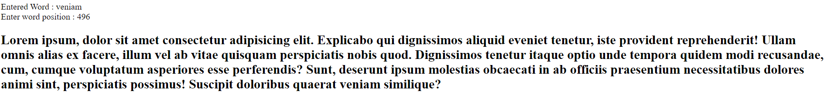

1. **Write a JavaScript to print characters of a string at odd positions. (for example, for the string India, I, d and a should get printed)**

<!DOCTYPE html>

<html lang="en">

<head>

<meta charset="UTF-8" />

<meta http-equiv="X-UA-Compatible" content="IE=edge" />

<meta name="viewport" content="width=device-width, initial-scale=1.0" />

<title>DISHEN</title>

<script>

function isString(event) {

var charCode = event.keyCode;

if (charCode < 65 || charCode > 123) {

return false;

}

return true;

}

function fun() {

let string = String(document.getElementById('string').value);

for (let i = 0; i < string.length; i++) {

if (i % 2 == 0) {

document.write(string[i] + ', ');

}

}

}

</script>

</head>

<body>

Enter a String :

<input type="text" id="string" onkeypress="return isString(event)" />

<input type="button" onclick="fun()" value="check" />

<br />

<p id="ans"></p>

</body>

</html>





1. **Write a JavaScript to take 2-digit number and then separate these 2 digits, then multiply first digit by itself for second digit times. (for example, 23 should be separated as 2 and 3. 2 should multiply with itself 3 times).**

<!DOCTYPE html>

<html lang="en">

<head>

<meta charset="UTF-8" />

<meta http-equiv="X-UA-Compatible" content="IE=edge" />

<meta name="viewport" content="width=device-width, initial-scale=1.0" />

<title>DISHEN</title>

<script>

let number = prompt('Enter 2 digit number');

// console.log(number);

let isnum = /^\d+$/.test(number);

// console.log(isnum);

if (isnum) {

let ans = 1;

// console.log(number.toString().length);

// console.log(number.toString().charAt(1));

if (number.toString().length == 2) {

for (var i = 0; i < number.toString().charAt(1); i++) {

ans *= Number(number.toString().charAt(0));

}

document.write('Answer is : ' + ans);

} else {

document.write('Please enter only 2 digit number');

}

} else {

document.write('Please enter a number');

}

</script>

</head>

</html>

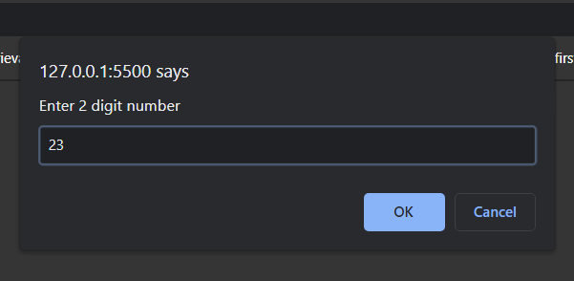



**6. Write a JavaScript that handles following mouse events. Add necessary elements. Show the use of event in following:**

**a. If the mouse is over the heading, heading should turn yellow and if the mouse goes out of the heading it should turn black.**

**b. If find time button is clicked show time and date information.**

**c. If button named “red” is clicked, background should change to red and If button named “green” is clicked, background should change to green.**

<html>

<head>

<title>Mouser Effect & Hover & Click</title>

<script type="text/javascript">

function time_find() {

var t = new Date();

document.getElementById('display').innerHTML = t;

}

function to_red(color) {

document.body.style.background = 'red';

}

function to_green() {

document.body.style.background = 'green';

}

</script>

</head>

<body>

<h1 id="heading">This is heading tag</h1>

<script>

document

.getElementById('heading')

.addEventListener('mouseover', mouseOver);

document

.getElementById('heading')

.addEventListener('mouseout', mouseOut);

function mouseOver() {

document.getElementById('heading').style.color = 'yellow';

}

function mouseOut() {

document.getElementById('heading').style.color = 'black';

}

</script>

<br />

<br />

<input type="button" value="Find Time" onclick="time_find();" />

<div id="display"></div>

<br />

<br />

<button onclick="to_red()" style="background-color: red" ;>

Click here

</button>

<button onclick="to_green()" style="background-color: green" ;>

Click here

</button>

</body>

</html>

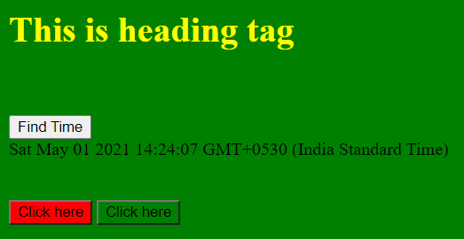

**Assignment 8**

**Study and Implement PHP with variables, function, procedure and various operation.**

1. **Demonstrate the use of associative array in PHP.**

<?php

$age = array("john" => "doe", "Raj" => "Soni", "Shyam" => "patel");

foreach ($age as $x => $x_value) {

echo "Name=" . $x . ", Surname=" . $x_value;

echo "<br>";

}

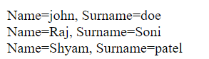

1. **Demonstrate the use of Session & Cookie in PHP.**

<?php

session_start();

$cookie_name = "user";

$cookie_value = "John Doe";

setcookie($cookie_name, $cookie_value, time() + (86400 * 30), "/"); // 86400 = 1 day

?>

<!DOCTYPE html>

<html>

<body>

<?php

$_SESSION["favcolor"] = "green";

$_SESSION["favanimal"] = "cat";

echo "Session variables are set. <br>";

echo "Favorite color is " . $_SESSION["favcolor"] . ".<br>";

echo "Favorite animal is " . $_SESSION["favanimal"] . ".<br>";

if (!isset($_COOKIE[$cookie_name])) {

echo "Cookie named '" . $cookie_name . "' is not set!";

} else {

echo "Cookie '" . $cookie_name . "' is set!<br>";

echo "Value is: " . $_COOKIE[$cookie_name];

}

?>

</body>

</html>

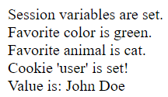

1. **Write a program to upload image file with size less than 2MB.**

**upload-file.php**

<html>

<head>

<title>File Upload Form</title>

</head>

<body>

<form action="upload-manager.php" method="post" enctype="multipart/form-data">

<h2>Upload File</h2>

<label for="fileSelect">Filename:</label>

<input type="file" name="photo" id="fileSelect">

<input type="submit" name="submit" value="Upload">

<p><strong>Note:</strong> Only .jpg, .jpeg, .gif, .png formats allowed to a max size of 5 MB.</p>

</form>

</body>

</html>

**upload.php**

<?php

if ($_SERVER["REQUEST_METHOD"] == "POST") {

if (isset($_FILES["photo"]) && $_FILES["photo"]["error"] == 0) {

$allowed = array("jpg" => "image/jpg", "jpeg" => "image/jpeg", "gif" => "image/gif", "png" => "image/png");

$filename = $_FILES["photo"]["name"];

$filetype = $_FILES["photo"]["type"];

$filesize = $_FILES["photo"]["size"];

$ext = pathinfo($filename, PATHINFO_EXTENSION);

if (!array_key_exists($ext, $allowed)) die("Error: Please select a valid file format.");

$maxsize = 2 * 1024 * 1024;

if ($filesize > $maxsize) die("Error: File size is larger than the allowed limit.");

if (in_array($filetype, $allowed)) {

if (file_exists("upload/" . $filename)) {

echo $filename . " is already exists.";

} else {

move_uploaded_file($_FILES["photo"]["tmp_name"], "upload/" . $filename);

echo "Your file was uploaded successfully.";

}

} else {

echo "Error: There was a problem uploading your file. Please try again.";

}

} else {

echo "Error: " . $_FILES["photo"]["error"];

}

}

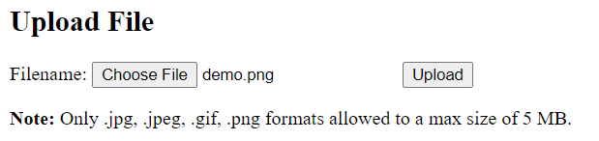

**4. Write PHP programs to**

**a.To print whether entered year is leap year or not.**

<html>

<body>

<h2>PHP Script to find Leap year or not</h2>

<form action="" method="post">

<input type="text" name="year" />

<input type="submit" />

</form>

</body>

</html>

<?php

if ($_POST) {

$year = $_POST['year'];

if (!is_numeric($year)) {

echo "Strings not allowed, Input should be a number";

return;

}

if (($year % 4 == 0) and ($year % 100 != 0) or ($year % 400 == 0)) {

echo "$year is a leap year";

} else {

echo "$year is not a leap year";

}

}

?>

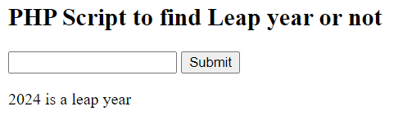

**b. To print whether current year is leap year or not.**

<html>

<body>

<h2>PHP Script to find current year is leap year or not</h2>

</body>

</html>

<?php

$year = date("Y");

if ((0 == $year % 4) and (0 != $year % 100) or (0 == $year % 400)) {

echo "$year is a leap year";

} else {

echo "$year is not a leap year";

}

?>

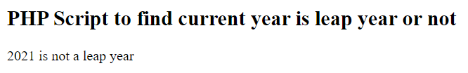

**c. To print whether given number is odd or even.**

<html>

<body>

<h2>Check enter number is odd or even</h2>

<form action="" method="post">

<input type="number" name="number" />

<input type="submit" />

</form>

</body>

</html>

<?php

if ($_POST) {

$number = $_POST['number'];

if (!is_numeric($number)) {

echo "Strings not allowed, Input should be a number";

return;

}

if ($number % 2 == 0) {

echo "$number is even";

} else {

echo "$number is odd";

}

}

?>

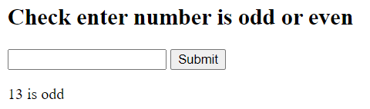

**Assignment 9**

**Develop small Database application with PHP with insert, update, delete and search record from database.**

**1. Write module using php and html to insert, delete and show employee info: id,name, job title, year of experience in employee table and output the information in ascending order of its experience.**

**showdb.php**

<html>

<head>

<title>Database</title>

</head>

<body>

<?php

$servername = "localhost:3306";

$username = "root";

$password = "";

$dbname = "employee";

$conn = new mysqli($servername, $username, $password, $dbname);

if ($conn->connect_error) {

die("Connection failed: " . $conn->connect_error);

}

$sql = "SELECT * FROM employee_master";

$result = $conn->query($sql);

if ($result->num_rows > 0) {

?>

<table cellpadding="4px" cellspacing="2" border="1">

<tr>

<td>Employee Id</td>

<td>Employee Name</td>

<td>Job title</td>

<td>Year of experience</td>

<td></td>

<td></td>

</tr>

<?php

while ($row = $result->fetch_assoc()) {

?>

<tr>

<td><?php echo $row["emp_id"] ?></td>

<td><?php echo $row["ename"] ?></td>

<td><?php echo $row["job"] ?></td>

<td><?php echo $row["expe"] ?></td>

<?php

$en = $row["emp_id"];

$que = "en=$en";

echo '<td><a href="update.php?' . $que . '"><button>Update</button></a></td>';

echo '<td><a href="delete.php?' . $que . '"><button>Delete</button></a></td>';

?>

</tr>

<?php

}

?>

</table>

<?php

} else {

echo "0 results";

}

$conn->close();

?>

<br><br>

<a href="insert.php"><button>Insert Record</button></a>

</body>

</html>

**insert.php**

<html>

<head>

<title>Employee Registration Form</title>

</head>

<body>

<?php

$servername = "localhost:3306";

$username = "root";

$password = "";

$dbname = "employee";

$conn = mysqli_connect($servername, $username, $password, $dbname);

if (!$conn) {

die("Connection failed: " . mysqli_connect_error());

}

if ($_SERVER["REQUEST_METHOD"] == "POST") {

$emp_id = $_REQUEST['emp_id'];

$ename = $_REQUEST['ename'];

$job = $_REQUEST['job'];

$expe = $_REQUEST['expe'];

$sql =

"INSERT INTO `employee_master` (emp_id, ename, job, expe) VALUES ('$emp_id','$ename','$job','$expe')";

if (mysqli_query($conn, $sql)) {

echo "New record created successfully";

} else {

echo "Error: " . $sql . "<br>" . mysqli_error($conn);

}

}

mysqli_close($conn);

?>

<br>

<form action="" method="post">

Employee Id : <input type="text" name="emp_id">

<br><br>

Employee Name : <input type="text" name="ename" placeholder="Enter Your Name">

<br><br>

Job title : <input type="text" name="job">

<br><br>

Year of experience : <input type="text" name="expe">

<br><br>

<input type="submit" value="Register">

</form>

<a href="showdb.php"><button>Show Database</button></a>

</body>

</html>

**update.php**

<html>

<head>

<title>Employee Update Data Form</title>

</head>

<body>

<?php

$servername = "localhost:3306";

$username = "root";

$password = "";

$dbname = "employee";

$en = $_GET["en"];

$conn = mysqli_connect($servername, $username, $password, $dbname);

if ($conn->connect_error) {

die("Connection failed: " . $conn->connect_error);

}

if ($_SERVER["REQUEST_METHOD"] == "POST") {

$emp_id = $_REQUEST['emp_id'];

$ename = $_REQUEST['ename'];

$job = $_REQUEST['job'];

$expe = $_REQUEST['expe'];

$sql = "UPDATE employee_master SET emp_id='$emp_id',ename='$ename',job='$job',expe='$expe' WHERE emp_id=$en";

if (mysqli_query($conn, $sql)) {

echo "One record updated successfully";

} else {

echo "Error: " . $sql . "<br>" . mysqli_error($conn);

}

}

$sql = "SELECT * FROM employee_master where emp_id=$en";

$result = $conn->query($sql);

while ($row = $result->fetch_assoc()) {

?>

<form action="" method="post">

Employee Id : <input type="text" name="emp_id" value="<?php echo $row["emp_id"] ?>">

<br><br>

Employee Name : <input type="text" name="ename" placeholder="Enter Your Name" value="<?php echo $row["ename"] ?>">

<br><br>

Job title : <input type="text" name="job" value="<?php echo $row["job"] ?>">

<br><br>

Year of experience : <input type="text" name="expe" value="<?php echo $row["expe"] ?>">

<br><br>

<input type="submit" value="Update Record">

</form>

<?php } ?>

<a href="showdb.php"><button>Show Database</button></a>

</body>

</html>

**delete.php**

<?php

$servername = "localhost:3306";

$username = "root";

$password = "";

$dbname = "employee";

$conn = new mysqli($servername, $username, $password, $dbname);

if ($conn->connect_error) {

die("Connection failed: " . $conn->connect_error);

}

$en = $_GET["en"];

$sql = "DELETE FROM employee_master WHERE emp_id=$en";

if ($conn->query($sql) === TRUE) {

echo "Record deleted successfully";

header("Location: http://localhost/WP/showdb.php");

} else {

echo "Error deleting record: " . $conn->error;

}

$conn->close();

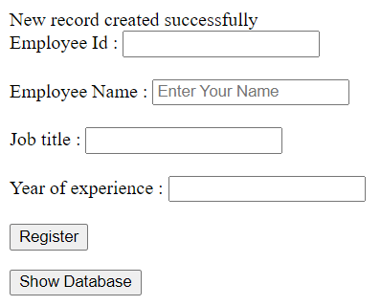

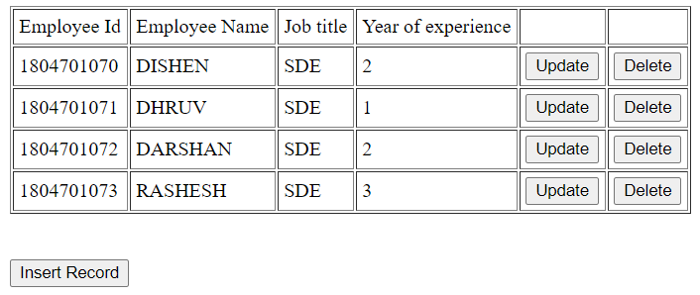

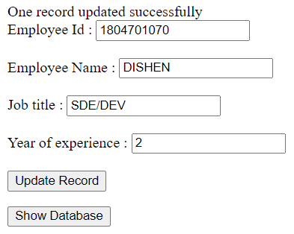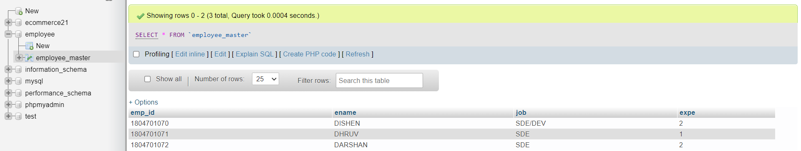

**Assignment 10**

**Study and Implement AJAX, jQuery basic operation.**

1. **Write a program that retrieve the content from text file using JQuery & AJAX.**

<!DOCTYPE html>

<html>

<body>

<div id="demo"><h2>Loading content From text file</h2></div>

<button type="button" onclick="loadDoc()">Show Content of text file</button>

<script>

function loadDoc() {

var xhttp = new XMLHttpRequest();

xhttp.onreadystatechange = function() {

if (xhttp.readyState == 4 && xhttp.status == 200) {

document.getElementById("demo").innerHTML = xhttp.responseText;

}

};

xhttp.open("GET", "demo.txt", true);

xhttp.send();

}

</script>

</body>

</html>

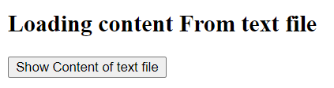

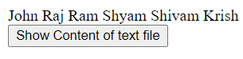

1. **Write a program that validate entered username from PHP array using AJAX.**

**suggest.html**

<html>

<head>

<script>

function showHint(str) {

if (str.length == 0) {

document.getElementById('txtHint').innerHTML = '';

return;

} else {

var xmlhttp = new XMLHttpRequest();

xmlhttp.onreadystatechange = function () {

if (this.readyState == 4 && this.status == 200) {

document.getElementById(

'txtHint'

).innerHTML = this.responseText;

}

};

xmlhttp.open('GET', 'validate.php?q=' + str, true);

xmlhttp.send();

}

}

</script>

</head>

<body>

<p><b>Start typing a name in the input field below:</b></p>

<form action="">

<label for="fname">First name:</label>

<input

type="text"

id="fname"

name="fname"

onkeyup="showHint(this.value)"

/>

</form>

<p>Result: <span id="txtHint"></span></p>

</body>

</html>

**validate.php**

<?php

$a[] = "John";

$a[] = "Mike";

$a[] = "Mihir";

$a[] = "Ram";

$a[] = "Raj";

$a[] = "Shyam";

$query = $_REQUEST["q"];

$hint = "";

if ($query !== "") {

$query = strtolower($query);

$len = strlen($query);

foreach ($a as $name) {

if (stristr($query, substr($name, 0, $len))) {

if ($hint === "") {

$hint = $name;

} else {

$hint .= ", $name";

}

}

}

}

echo $hint === "" ? "User Doesn't Exist" : $hint;

